Baseball Pocket General Manager

David Graves
Colorado State University Global
CSC510
Dr. Bingdong Li
October 24, 2025

Baseball: Metric Driven Decisions
With the excitement of the World Series in the crisp Fall air it’s easy to get caught up in the nostalgia and get lost in the history of America’s game. A game that was born in Cooperstown New York 180 years ago by a Civil War hero named Abner Doubleday. Although the economics and culture of the game have changed immensely over that time, the pitching mound is still 60’6” from home plate, the bases are all still 90’ apart from each other, and you still only get three strikes before you’re out. For the history of this game, we’ve kept track of almost every statistic imaginable including hits, errors, runs, and everything else to explain how the previous day’s game turned out and how the players performed. We can thank an Englishman, Henry Chadwick, for giving us the first box score in 1859 which was, “a set of statistics accounting for the runs, hits, put-outs, assists and errors compiled by the dominant team of the era, the Brooklyn Excelsiors, in their defeat at the hands of the upstart Brooklyn Stars.” (Pesca, 2009) We still use an amalgamation of his box score today with his statistics alongside many others to help us understand how players performed and how the games turned out. These are the same statistics that also inform other important team decisions, like who should be on the team roster. The teams we see on the field for this Fall’s Classic didn’t just agree to sign up and play together but were carefully constructed rosters that have been assembled by many different team personnel represented in one person, the General Manager (GM). GM’s have a difficult task every season in trying to make sense of reams of data and interviews when trying to fill a few open slots for the upcoming year. Each season teams are given the opportunity to participate in the Major League Baseball Draft in July, where they can select from a pool of eligible prospects to join their team. This is high stakes, where if you have the foresight and ability to pick the next Shohei Ohtani then you could see your team lift the trophy at the end of the season, but you could also just as easily pick the next ‘bust’ and end up having to watch the World Series from your couch at home instead of participating in it. Sounds easy if you just make the right selection, but what is the right selection to make? Mike Rosenbaum (2018) reports that “only 66 percent of first-round picks play in the majors”, so obviously this is not an exact science. With the wealth of statistical information, we have available to us thanks to box scores, I believe the 34 percent gap represents an opportunity that Artificial Intelligence can help with. Over the remainder of this paper, I’ll share a novel application leveraging an Artificial Neural Network, Intelligent Search Methods and Classifiers to assist a GM in choosing the best player from the draft. In doing so, I’ll show the tools I leveraged and other aspects of the program to explain how it represents and outputs knowledge that the GM can use.
Application Detail
One of the first decisions I had to make in developing this application was choosing what ‘AI’ approach to use that would then inform what tools to deploy. I opted for an ensemble model using an Artificial Neural Network to do heavy lifting to train on previous data and regression to predict future player statistics since there is, “general consensus that ensemble models produce more robust and reliable information for business decisions.” (Sharda & Delen & Turban, 2024) Specifically, I used the ‘MLPRegressor’ tool kit from ‘sklearn’ for this work. I also used ‘RandomForestClassifier’ to predict the proposed players tier that they belong to and leaned on a brute force search method to compute Euclidean distances between the predicted stats of my player and every other player in the dataset to return the closest comparable players. With the tools and methods basically worked out I needed to find a good dataset that I could train with, so I turned to Major League Baseball’s website to download the last 10 years of batting statistics for all major leaguers. There are many ways to view a player’s value, and I chose to focus on mainly batting statistics for this application since I don’t have access to scouting reports and other ‘fuzzy’ measurements. This program trains on that data using expert system concepts represented by an overall hybrid approach including rules for player tier thresh holds and similar player search and case retrieval. It uses a small Machine Learning feed forward neural network to ‘learn’, which some may argue may or may not be true deep learning. For this use-case it should suffice, however. The application represents knowledge via tables of statistics retrieved from a local .csv file and symbolic planning is not explicitly used here since it uses data and rules mainly instead of representing actions or goals. In the end I was able to produce a working interactive algorithm that allows a user (GM) to key in a prospect’s previous year’s batting statistics and outputs a reasonable prediction on how that player will perform across those statistics in the Major Leagues the following year. It also provides a tiered rating for the player and returns the next 3 closest players from the existing data set as comparable players to your predicted player. You’ll find the images for the algorithm ‘Pocket_GM_ANNFinal.py’ as well as output responses from my hypothetical player “Dr. Li” on the following pages.
Directions for Program Execution
I’ve included the file ‘Pocket_GM_ANNFinal.py’ and the data set that I used to train with ‘.csv’ which I pretrained and provided models that can be executed by double clicking the ‘.\Pocket_GM_ANNFinal.exe’. From there key in values for the different statistical queries noting the proper input value structure. Please note that on my computer the program took about 15 minutes to train on the data set provided so I gave you a pretrained set, however you can train with the included ‘.csv’ file if you wish. The program should output your predicted player’s following year statistics, player tier, and the three closest comparable players.

Image 1 (.py Code 1)
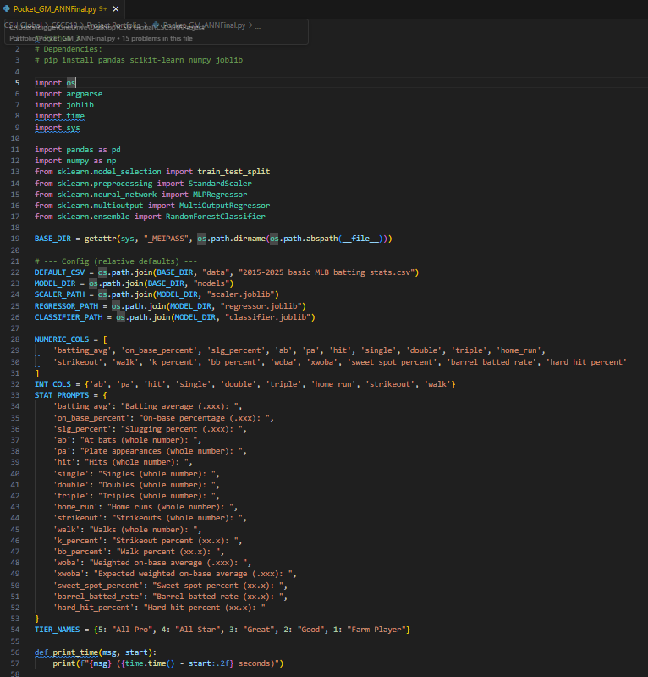

Image 2 (.py Code 2)
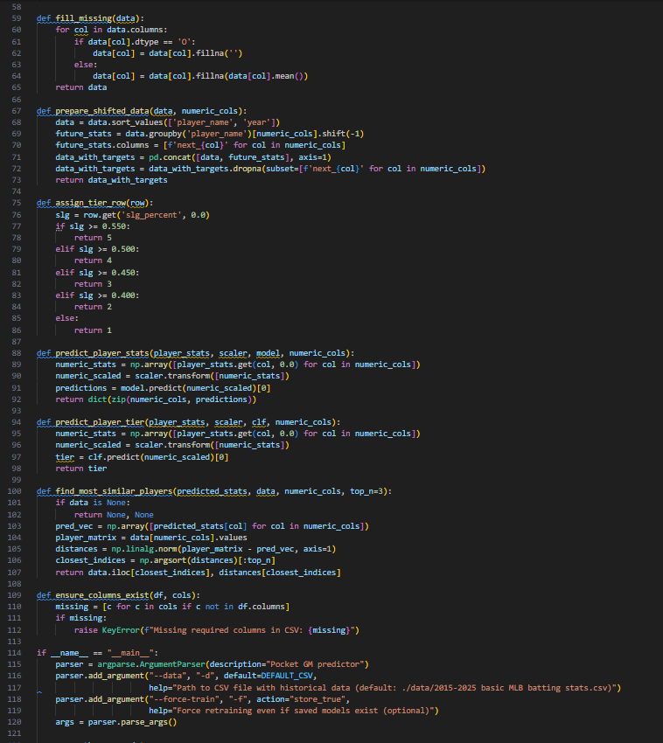

Image 3 (.py Code 3)
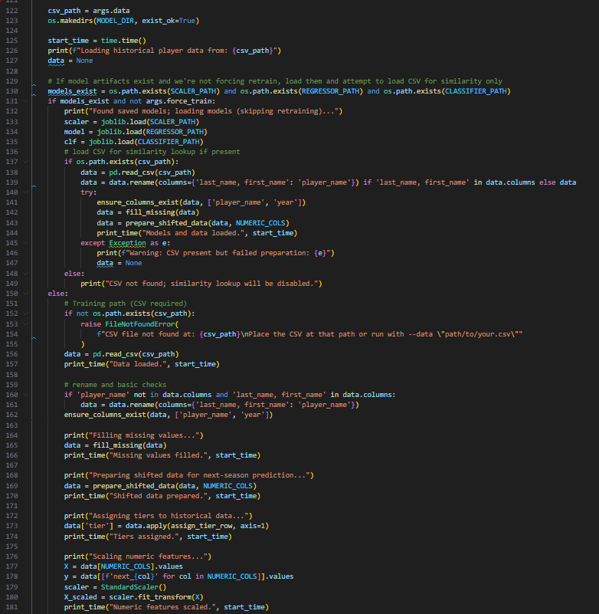

Image 4 (.py Code 4)
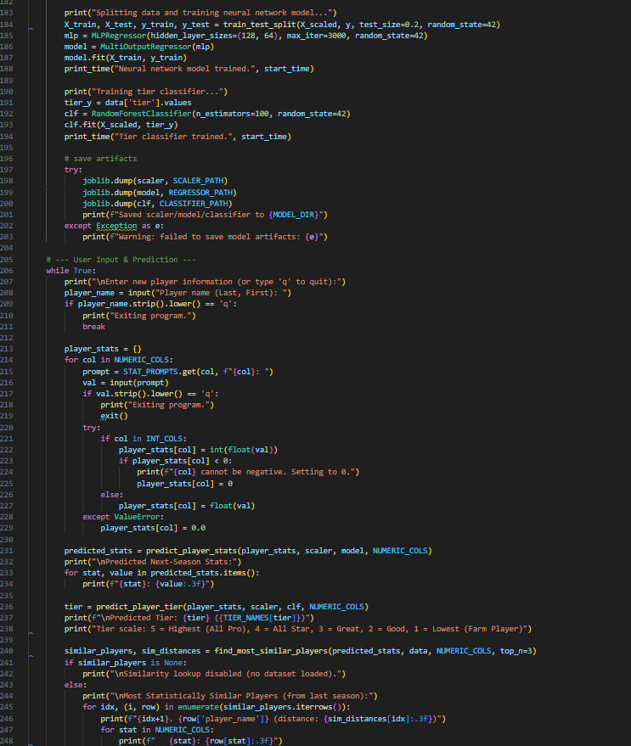

Image 5 (Output 1)
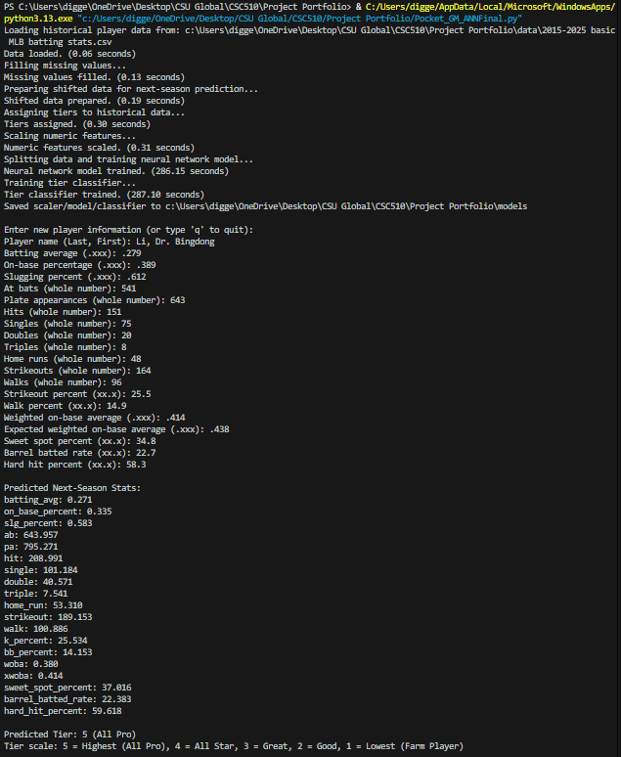

Image 6 (Output 2)
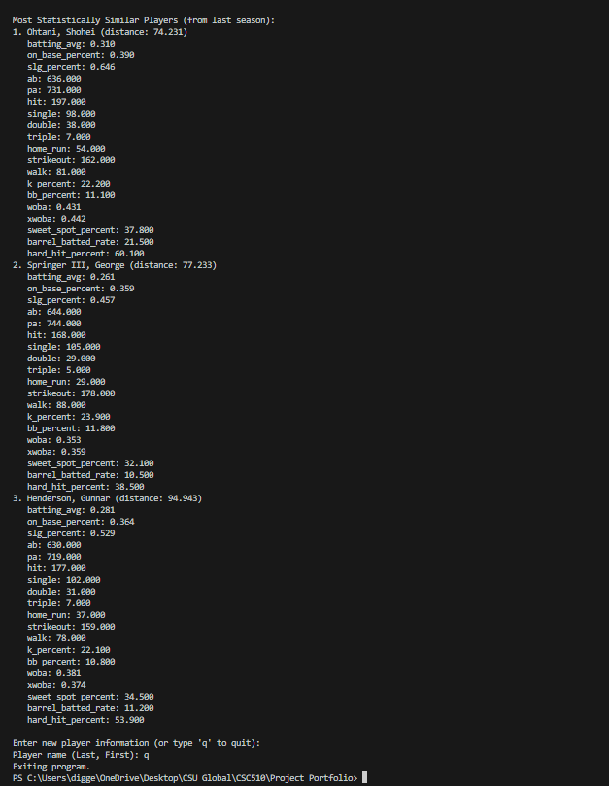
References
Pesca, Mike (2009, July 30). NPR.org. The Man Who Made Baseball’s Box Score a Hit.
https://www.npr.org/2009/07/30/106891539/the-man-who-made-baseballs-box-score-a-hit
Rosenbaum, Mike (2018, June 7). Examining the Percentage of MLB Draft Picks Who Reach
the Major Leagues. Bleacherreport. https://bleacherreport.com/articles/1219356-examining-the-percentage-of-mlb-draft-picks-that-reach-the-major-leagues
Sharda, Ramesh & Delen, Dursun & Turban, Efraim (2024). Business Intelligence, Analytics,
Data Science, and AI. Pearson Education Limited.

